The Cinderloo Story
Introduction
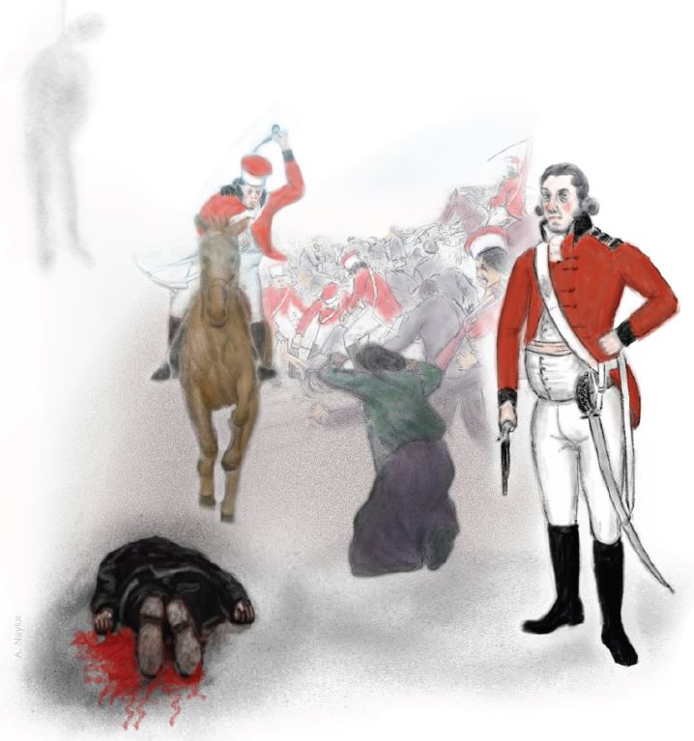
The Cinderloo Uprising was an industrial dispute that happened in the early 19th Century in the small East Shropshire town of Dawley, now part of Telford. The events took place during February to April 1821. This document is based on reports made at that time in the Salopian Journal and Shrewsbury Chronicle newspapers, and in records of the Shropshire Yeomanry.
The dispute started with about 500 miners protesting pay cuts enforced by local ironmasters. It grew to a crowd of over 3,000 massed on slag heaps and pit mounds, known as the Cinder Hills, located at Old Park, now the Forge Retail Park.
Illustration by Andrew Naylor
After marching to various ironworks and pits in the area to cause works to stop and persuade miners to join their action, the miners came into conflict with the Shropshire Yeomanry. As there was not a police force as we know it today, the Yeomanry were a group of armed men that were called into action to control criminal behaviour and keep the peace. The Shropshire Yeomanry represented the interests of the local Iron Masters, they numbered 70 men and were led by Lieutenant Colonel William Cludde.
As a direct result of the conflict, three men lost their lives:
Thomas Palin, hanged on 7th April 1821.
William Bird, an 18 year old collier was killed outright.
Thomas Gittens (Ingle), was mortally wounded.
Others involved included Samuel Hayward (who was also initially condemned to death but later reprieved) while John Amies, Joseph Eccleshall, John Grainger, Christopher North, John Payne, Robert Wheeler and John Wilcox who were each sentenced to 9 months imprisonment with hard labour for riot.
The Shropshire Yeomanry incurred minimal casualties.
Like the Peterloo Massacre, which took place two years earlier in 1819 in Manchester, Cinderloo was so named in ironic reference to the Battle of Waterloo, which ended the Napoleonic War in 1815.
The Events
The Years leading up to 1821
Over Production…
During the Napoleonic Wars, the industrial revolution in Shropshire was booming in order to supply necessary iron and materials. However, in the following years, the small mining and foundry towns of Shropshire were in rapid economic decline. This is because there was a reduced need for iron and the market price fell, while the large iron works in the Welsh Valleys were more successful in trading.
The country was in recession and large numbers of men returning from the Wars found it difficult to get jobs. Protests about food and working conditions were taking place in many industrial areas of the country. The Government, fearful of a similar revolution to that which happened in France in 1789, imposed greater controls to prevent people gathering in large groups or publishing political writing.
Discontent Brews…
The local Ironmasters, who owned the ironworks, and chartermasters, who employed the miners, decided to take action by making their workers pay for their crisis. In 1820, the year before the Cinderloo Uprising, the ironmasters tried to cut wages of the miners, who reacted by striking.
“On that occasion, Colonel Cludde of the Shropshire Yeomanry persuaded the strikers to accept arbitration by a board of four landowners and a clergy man, who agreed that the men were entitled to their old level of wages and the strike was called off”. (Trinder, 2000)
In 1821, the ironmasters were more determined to enforce a pay cut. They announced a cut of sixpence (6d) a day on the workers on Saturday 27th January 1821. A typical day’s wage for a collier was around two shillings (24d).
Unsurprisingly, the coal miners, known as colliers, were deeply unhappy about this, since they were already suffering terrible working conditions and poverty. The pay cut would push the miners and their families further into poverty, as they already faced high prices of bread, lack of food and a rise in deadly diseases such as Cholera and Smallpox.

Thursday 1st February 1821 - The day before the Riot
Two days after the announcement that wages were to be reduced, the colliers went on strike. On 1st February, pits that were still working were visited by the strikers, who persuaded the employees to join them. Following visits to ironworks at Ketley, New Hadley and Wombridge, production was brought to a halt by the plugging of boilers. The steam boilers were needed to power the iron works machinery. (Trinder, 2000)
Friday 2nd February 1821 – The Riot or Battle of Cinderloo
It was intended to carry on that disruption at the works in the Southern part of the coalfield. 500 workers marched from Donnington Wood to the large iron works at Old Park, owned by the Botfield family. Once again, the boilers were plugged and the casting bell rung to encourage workers to stop work and join them.
They marched on to the collieries at Stirchley and ironworks at Dawley Castle. The crowd divided with one group heading to the works at Horsehay and the other reaching Lightmoor furnaces by noon, where again they caused damage and brought machines to a halt. Workers from the mines and ironworks visited were called to join the march. Feelings ran high, resulting in damage to the pit heads, whilst some miners were threatened unless they stopped work.
They then intended to continue on to Coalbrookdale, the crowd having increased to over 2,000, but their plans changed when they heard that the colliery owners had sent out appeals for help, calling out 70 men of the Shropshire Yeomanry, led by Colonel William Cludde from Wellington Barracks to support the local constabulary, who were outmatched, to calm the angry miners.
The crowd of colliers was, by this time, around 3,000 strong. ‘Numbers of women and children had joined them on their route’ and they had gathered on and around the high, steep slopes of cinder hills that dominated the landscape surrounding the now idle ironworks. (Salopian Journal, 1821). The cinder hills were made up of large lumps of slag and waste materials from the iron making process.
Violence Erupts…
The crowd was determined to put a stop to the proposed pay cuts. They were met by a magistrate, Thomas Eyton, accompanied by other men of law, the soldiers of the Yeomanry on horseback, armed with pistols and sabres and Lieutenant-Colonel Cludde, who remained in in his carriage. Eyton started to read the Riot Act proclamation at around 10 minutes to three, which instructed everyone to disperse peacefully within one hour
This was met with jeers and defiance, while a period of one hour was allowed during which the ‘crowd remained very noisy and did not disperse.’ (Trinder, 2000). The crowd were armed with sticks and crude mining tools, others picking up stones and lumps of cinders from the foot of the hills began to attack the troops. They shouted “We will have our Wages!” “If we are to fight for it, let’s all get together!”
Eight suspect ring leaders including Samuel Hayward, a man known only as Hassall and others were captured and taken into custody. The crowd tried to stop the troops taking them back to Wellington pelting the Yeomanry with slag and stones. Under the alleged leadership of Thomas Palin, a successful attempt was made to rescue the prisoners.
Cludde, now took charge and gave the order for ‘the cavalry to advance, to endeavour to disperse them doing as little injury as possible…and at the same time to assist the Peace Officers in taking into Custody any that were armed, or who appeared to be particularly active.’ (Cludde, 1821, 4th February)
In the confusion, soldiers opened fire and collier William Bird was shot dead; another Thomas Gittens, a miner from Lawley Bank died from his wounds. (Cludde, 1821, 4th February) Hayward and other miners were recaptured by the troops and put into the custody of John Bayley, a constable of Malinslee. (Salopian Journal, 1821)
More gunshots were fired, and the protesters began to disperse.
Some of the Yeomanry were said to have been injured by slag and stones but only one Cavalryman, David Spencer of Trench Lane had a serious injury – accidently shooting himself in the knee. (Salopian Journal, 1821)
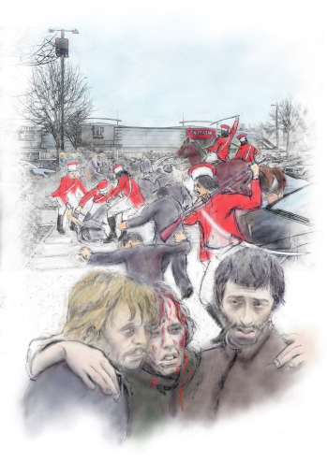
The days following the battle
Two troops of the Shrewsbury Yeomanry (under Captain Jenkins and Captain Lloyd) and staff of the Shropshire Militia under Captain Mortimer joined the troops of the Wellington Yeomanry led by Lieutenant-Colonel Cludde on Saturday 3rd February to patrol the area and ensure there was no further trouble. This force was further increased on Sunday 4th February by the arrival of a Troop of the 6th Dragoon Guards from Shifnal.
Works commenced to repair damage at the Old Park works. The iron companies in the north of the coalfield including the Botfields and Lilleshall Compny agreed a compromise with their workforce to reduce wages by 4 pennies instead of 6. Other works at Coalbrookdale, Madeley Wood and Lightmoor imposed the full reduction.
Illustration by Andrew Naylor
Deaths and Arrests…
A number of colliers and bystanders were wounded, including Thomas Palin, who received an shot wound to the arm. When he visited a surgeon on 3rd February to have the wound dressed, this was evidence he had been at the riot and he was later arrested. (Cludde, 1821, 4th February)
At the inquest into the deaths of William Bird and Thomas Gittens on 6th February, the jury immediately returned verdicts of Justifiable Homicide. (Shrewsbury Chronicle, 1821)
The trial at the Shrewsbury Assizes
The arrested men taken were tried in court on March 25th at Shrewsbury Assizes. Of nine captives, Thomas Palin, the supposed ring leader and another Samuel Hayward, were sentenced to death on April 7th, 1821 for “felonious riot”.
Samuel Hayward was similarly sentenced to death, but was reprieved on 2nd April. (Shrewsbury Chronicle, 1821)
The other miners named in the local press as John Amies, Joseph Eccleshall, John Grainger, Christopher North, John Payne, John Wilcox, and Robert Wheeler earned nine months imprisonment with hard labour, for the lesser crime of riot.
The Execution
Despite appeals by his employers for a reprieve, Thomas Palin was hanged at the County Gaol in Shrewsbury, known as The Dana Prison, on 7th April, 1821, and later buried in Shifnal.

Discussion Points
What did the Cinderloo Uprising achieve?
In the short term, the protest resulted in a reduction in the pay cut from 6d per day to 4d per day for only those collieries operating in the north of the East Shropshire Coalfield. Other mines suffered the full 6d per day cut. (Trinder, 2000)
While those achievements may seem modest, considering the loss of life, the Cinderloo Uprising played a part in the struggle for social justice that led on to Chartism and ultimately to a sea change in the UK political landscape. The most obvious results of this being the eventual legalisation of trade unions and the resulting improvements in workers’ rights, pay and conditions.
Can the violence used by the miners be justified?
What else could the miners have done to oppose the pay cut?
How have workers rights changed in present times?

References
(1821, February 9th). Shrewsbury Chronicle.
(1821, March 28th). Salopian Journal.
(1821, March 30th). Shrewsbury Chronicle.
(1821, April 11th). Salopian Journal.
(1821, April 13th). Shrewsbury Chronicle.
Baggs, A., Cox, D., McFall, J., Stamper, P. A., & Winchester, A. (1985). Dawley: Economic History. A History of the County of Shropshire: Volume 11. ed. GC Baugh and CR Elrington, 115-125 [accessed 22nd March 2019].
Cludde, W. e. (1821, 4th February). Letter to Home Office, PRO HO 40/16/15.
Coxill, D. (n.d.). Coalbrookdale Coalfield. SCMC Journal No.3.
Coxill, D. (n.d.). Review of the Geological Memoir of Telford and the Coalbrookdales Coalfield. SCMC Journal No.5.
Coxill, D., & Lake, K. (n.d.). Coalbrookdale Coalfield. Mining in Shropshire.
Gladstone, E. (1953). Shropshire Yeomanry. Manchester: Whitehorn Press.
Morton, A. L. (1938). A People's History of England.
Navickas, K. (2017). Protest and the politics of space and place, 1789–1848. Manchester University Press.
Raistrick, A. (1989). Dynasty of Iron Founders: The Darbys and Coalbrookdale. William Sessions.
Thompson, E. (2013). The Making of the English Working Class. London: Penguin.
Trinder, B. (2000). The Industrial Revolution in Shropshire, Third Edition. Chichester: Phillimore.
White, I. (2004). "Cinderloo": Riot, Repression and Revivalism in the East Shropshire Coalfield 1821-22. Wolverhampton: University of Wolverhampton.

